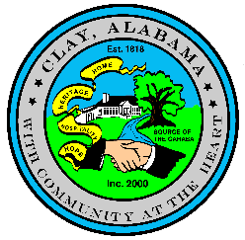
CITY OF CLAY, ALABAMA
ORDINANCE 2025-01

AN ORDINANCE TO AMEND ORDINANCE 2003-103,

AN ORDINANCE TO REGULATE THE SALE OF ALCOHOLIC BEVERAGES

WHEREAS, the City Council of the City of Clay, Alabama adopted Ordinance 2003 –103 on January 5, 2004; and,

WHEREAS, the provisions of this Ordinance, including the fee schedule, may from time to time be amended, supplemented, changed, modified, or repealed by the City Council.

NOW, THEREFORE, BE IT ORDAINED, by the City Council of the City of Clay, Alabama that subsection E to Section XI of Ordinance 2003-13 shall be amended to read as follows:
E. The number of Lounge Retail Liquor Class II as categorized by the Alabama Alcoholic Beverage Control Board shall be limited to three (3) within a one-mile radius and no more than four (4) total within the City limits.

ADOPTED AND APPROVED this 11th Day of February, 2025.

___________________________ ATTEST: ____________________________
Charles K. Webster Ronnie Dixon
Mayor City Manager

CITY OF CLAY, ALABAMA
ORDINANCE 2025-01

I, the undersigned City Manager of the City of Clay, Alabama, do hereby certify that the above and foregoing is a true copy of one Ordinance lawfully passed and adopted by the City Council named therein, at a regular meeting of such Council, and that such resolution is on file in the City Clerk’s Office.

I further certify that said Ordinance was posted as required by State Law at the following locations: Clay City Hall; Clay Post Office, Clay Public Library and the Clay Seniors Center all being in the City of Clay.

IN WITNESS WHEREOF, I have hereunto set my hand and affixed the official seal of the City on this 12th day of February, 2025.

______________________________________
Ronnie Dixon
City Manager

